ODD EVEN NUMBERS

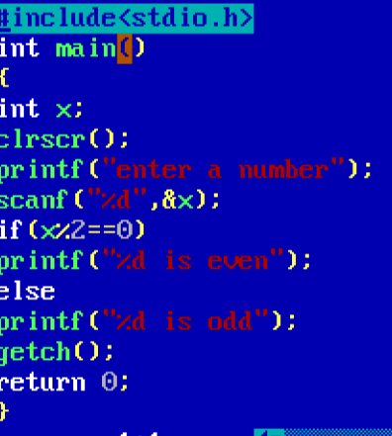

OUTPUT

